|  |  |
| --- | --- |
| **GAT150 – Introduction to Game Programming** |  |

***Image Loader***

***OVERVIEW***

In this assignment you will add an image library to handle loading of different image formats (.png, .jpg, .tga). This will allow the loading of image formats that support transparencies.

 

***GRADING***

This assignment is worth 25 points. To receive full credit, your engine must be able to load different image file formats.

***INSTRUCTIONS***

*This link also contains directions to setup your project to load different formats:*

<http://gigi.nullneuron.net/gigilabs/loading-images-in-sdl2-with-sdl_image/>

# Download the SDL_Image Library

* <https://www.libsdl.org/projects/SDL_image/>
  + Download the Development Libraries (Visual C++ 32/64-bit)
  + Place the .zip file in the Middleware folder

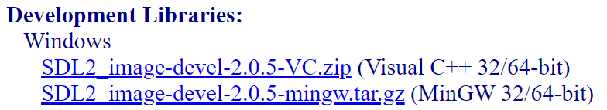

# Add the SDL_Image files to Middleware

* Unzip the SDL2_image-devel-2.0.5-VC.zip

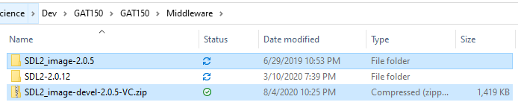

* Copy the include and lib directories from the extracted SDL2_image-2.0.5 folder

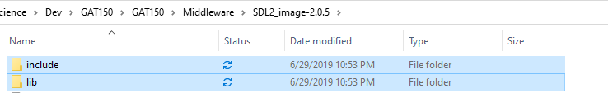

* Paste these into your middleware/SDL2-2.0.12 folder
  + This will *add* the .h and .lib/.dll files to the existing include and lib folders

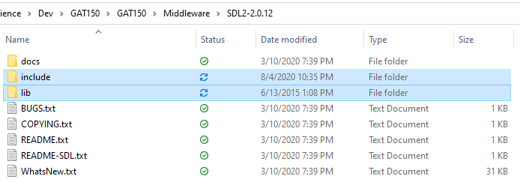

* *You can now delete the .zip file and the extracted folder, we are done with them*

# Add the SDL_Image Library to the Project

* Set the project to include the SDL2_image.lib
  + Open *Engine* Properties
  + Make sure you are on *All Platforms* and *All Configurations*
  + *Librarian>Additional Dependencies*
  + Since the Library Directories for the SDL .lib files have already been setup, we don’t need to set the directories for the libs

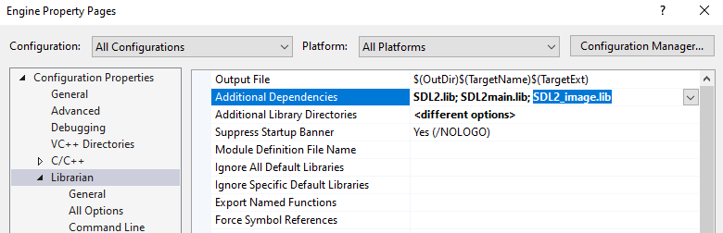

* + Copy the dll files from *Middleware\SDL2-2.0.12\lib\x86* and place it in the *Build* folder
    - Every .dll file except for *SDL2.dll*

|  |  |  |
| --- | --- | --- |
|  |  |  |

# Initialize the SDL_Image Library

**pch.h**

* Add the SDL_Image header to the precompiled header

#include "framework.h"

#include <SDL.h>

**#include <SDL_image.h>**

**Main.cpp**

* Include the header for the image library in Main.cpp

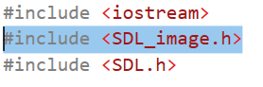

* To enable different image formats to be loaded, initialize the image types at the start of main *after* SDL_Init()

IMG_Init(IMG_INIT_JPG | IMG_INIT_PNG);

* + - You don’t have to specify BMP, it is already included
* Make sure to quit the image loader at the end of main *before* SDL_Quit()

IMG_Quit();

# Load the Image

**Texture.cpp**

* In Texture::Create use the function call IMG_Load
  + IMG_Load instead of SDL_LoadBMP
* In Main.cpp load “sf2.png” instead of “sf2.bmp”
  + You can use your own .png and .jpg if you’d like
  + The .png file contains alpha (transparency)
    - This allows the texture to have transparent areas

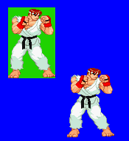

***RESOURCES***

<https://www.libsdl.org/projects/SDL_image/docs/index.html>

<http://gigi.nullneuron.net/gigilabs/loading-images-in-sdl2-with-sdl_image/>